**SCIENTIFIC COMMITTEE**

**TWENTY FIRST REGULAR SESSION**

Nuku’alofa, Tonga

13-21 August 2025

**Ecosystem and climate indicators of the western and central Pacific Ocean**

**WCPFC-SC21-2025/EB-WP-01**

**14 July 2025**

Nicholas J Hill1, Simon Nicol1, Joanne Potts1, Bernadette Sloyan2, Thomas Moore2, Pearse Buchanan2

Contents

Executive Summary 3

Introduction 4

Proposed indicators 6

Indicator X: Centre of gravity (COG) of the purse seine fishery 6

Indicator X: Size composition of tunas 11

References 15

Appendix 1: Terms of reference for adopting ecosystem and climate indicators 18

Appendix 2: Suva ecosystem and climate indicators workshop summary 20

Workshop agenda 20

Workshop participants 22

# Executive Summary

This Working Paper updates SC21 on progress regarding development of a climate and ecosystem indicators report for the western and central Pacific Ocean (WCPO).

The ecosystem and climate indicator recommendations of SC20 were:

* note the progress towards implementing the SC19 endorsed Ecosystem and Climate Indicators Workplan.
* note the delay in the first expert workshop due to travel disruptions associated with the civil disturbances through May-July in New Caledonia.

This working paper notes that a workshop was successfully held in Suva, Fiji 25-26th November 2024 that brought collaborators together from a range of organisations to inform development of a workplan and indicators.

A series of ecosystem and climate indicators have been proposed and presented since SC17. This paper presents further refinement of these candidate indicators and suggestion of several new ones with the commencement of collaboration from CSIRO. It also details a continued workplan…

### Recommendations

We invite WCPFC21 to note the results of this updated climate and ecosystem indicators report and present recommendations for future work:

* Note the successful undertaking of a workshop in Suva, Fiji in November 2024 that brought collaborators together from a range of organisations to inform development of a workplan and candidate indicators.
* Note the continued development and refinement of climate and ecosystem indicators for routine updating and presenting to future SC meetings.
* Note the need for continued support of research focused on developing methods that can identify and monitor climate change-related impacts on the WCPO and its associated fisheries.
* Note the updated workplan for ecosystem and climate indicators research for 2025-26.

# Introduction

The Western and Central Pacific Ocean (WCPO) contains major oceanic currents and circulation pathways. These pathways redistribute waters from different parts of the Pacific Ocean such as the North and South Pacific subtropical gyres to the equator and extra-tropical regions. The circulation of the WCPO is complex, with large currents that vary substantially and include asymmetries and gating effects across various timescales.

These complex currents carry water masses with distinct ocean properties (e.g. temperature, salinity, oxygen and nutrients). Changes in the intensity and position of these currents therefore influence broader trends in temperature, salinity, oxygen, and nutrient distribution of the WCPO. Adding to this ocean current and property variability, the El Niño-Southern Oscillation (ENSO) is the strongest interannual climate signal globally, profoundly influencing tropical and equatorial Pacific Ocean circulation and property distribution.

This variability in equatorial currents and associated climate phenomena have flow-on effects and consequences for marine ecosystems. Ocean circulation, including key processes like mixing, upwelling, and advection, along with the resulting temperature, salinity, and oxygen distributions, fundamentally shape marine ecosystems. Tunas and other highly mobile pelagic species are well known for moving with favourable environmental conditions related to temperature, productivity, and upwelling. As a result, fisheries adapt to these conditions, following shifts in the distribution of preferential environmental conditions and tuna dynamics to maximise catches. For example, there is a well-known eastward shift in purse seine effort and catch during el nino events due to an eastward expansion of the western pacific warm pool as a result of weakening trade winds and surface currents from the eastern pacific (Lehodey et al., 2020, 2003).

The environment and climate are continuously influencing tuna fisheries in the Pacific Ocean. Climate change will potentially influence and exacerbate these effects. For example, climate change predictions suggest an eastward expansion of the western pacific warm pool and with it, an eastward shift in tuna biomass (Bell et al., 2021; Weller et al., 2016). If tuna biomass does shift, this will have flow on effects to Pacific Island countries and territories (PICTs) which are highly dependent on fisheries for food security and as a source of income (Bell et al., 2015; Gillett and Fong, 2023). In response to the effects of climate change, fisheries administrations are increasingly looking at ways to monitor and adapt to its effects (Taylor and Walter, 2024).

Within tuna regional fisheries management organisations (RFMOs), climate and ecosystem indicator reports are now being regularly produced to monitor environmental conditions and to track if any underlying shifts in ecosystems, fisheries or species of interest are occurring (Griffiths and Fuller, 2019; Juan-Jordá et al., 2018; SPC, 2023). Since 2015, the WCPFC Scientific Committee (SC) has explored the development of ecosystem and climate indicators to help inform the management of fisheries targeting tuna and tuna-like species in the WCPO (Anon, 2015; Smith et al., 2016). A series of reports have subsequently been produced since SC11 in 2015 describing the objectives and testing criteria for these indicators, and a set of candidate indicators have been produced since 2019 at SC15 (Allain et al., 2021, 2020; Juan-Jordá et al., 2019; SPC, 2024, 2023, 2022). Text from previous SC papers that outlines the terms of reference and process for adopting these indicators is provided in Appendix 1 (Smith et al., 2016; SPC, 2022).

This report represents a continuation of this work in presenting a set of updated ecosystem and climate indicators for adoption by the SC. These indicators will help inform SC and the WCPFC Commission on the current state of the ecosystem and climate of the WCPO and any prevailing trends that are likely to influence the sustainability and management of tunas, their fisheries and surrounding ecosystems. The purpose of this report is that it will be adopted by the Commission and routinely produced to provide up-to-date information to the SC and WCPFC Commission to help inform decision-making and support its application of an ecosystem-based approach to fisheries management (EAFM).

As part of this ongoing work of developing ecosystem and climate indicators, a workshop was recently held in Suva, Fiji November 2024 to develop a workplan and discuss candidate indicators. Details of this workshop have been provided in Appendix 2. In summary, this workshop brought together approximately 25 participants both in person and online from a range of organisations including SPC, NOAA, WCPFC, private sector, NGOs and member country representatives. The intent of the workshop was to discuss the development of a series of indicators that accurately detail the current marine climate for the Pacific region and its fisheries so that it can better monitor and adapt to the effects of climate change.

### Objectives

The intent of this report is to present an up-to-date state of the ecosystem and climate report for the WCPO to help inform the management of tuna and tuna-like species by the WCPFC. The indicators intend to provide an outlook of the current state of the environment, natural variability and any underlying persistent changes across key oceanographic features and associated tuna fisheries that may affect their sustainability and management. Here, six indicators are presented that summarise the ecosystem and climate of the WCPO such as sea surface temperature variability and area of the western pacific warm pool as well as several fisheries indicators.

For selection, indicators had to meet the criteria detailed in Appendix 1 which required a combination of the indicator being reflective of the current environment, responsive to changes, cost effective, and science-based among others. Based on these criteria, the following indicators selected were:

1. Sea surface Temperature variability
2. Depth of the 20oC subsurface ocean isotherm and variability from the mean state
3. Area and volume of the western pacific warm pool and variability from the mean state
4. Depth and thickness of Oxygen depleted waters where oxygen depleted waters are defined as 1.5 - 3 mL/Litre (45-90 umol kg-1)
5. Chlorophyll/productivity?
6. Centre of gravity (COG) of the purse seine fishery
7. Area of longline and PS fishery?
8. Size composition of tunas

Below, a rationale for the inclusion of each indicator is given along with a summary of their status and trends over time.

# Proposed indicators

## Indicator X: Centre of gravity (COG) of the purse seine fishery

Rationale: The WCPFC purse seine fishery predominately operates in the western pacific warm pool. The warm pool is a large, warm body of water at or above 28oC that sits in the equatorial western pacific. The warm pool naturally varies in size and extent with changes in the environment, and in particular with ENSO events, which influences where effort and catch consequently occurs in the purse seine fishery (Senina et al., 2008). The warm pool is also considered as an important spawning ground for tuna species, in particular skipjack tuna and so changes in its size, structure or position may also influence the productivity of tuna (Ashida, 2020; Fujioka et al., 2024).

With the impacts of climate change, the warm pool is predicted to increase in size, driving a potential eastward shift in tuna biomass (Bell et al., 2021; Lehodey et al., 2013). By monitoring the centre of gravity (COG) of purse seine effort and catch, we can potentially monitor if fisheries are responding to these predicted changes and by proxy tuna dynamics. Any shift in the location of the purse seine fishery is also relevant as it relates to income for PICTs when fishing occurs in their EEZ.

Status: For effort, there is a clear distinction in trends over time by set type (Figure 1). For unassociated sets, effort COG shows interannual variability but no clear underlying trend from 1990-2023. In contrast, there is an eastward shift in the COG of drifting FAD-associated sets over time. It is difficult to determine if this is a climate related shift in the warm pool and tuna dynamics, or if it is a shift in fishing behaviour driven by increased uptake of FAD-associated fishing. Equally, the lack of movement in the unassociated set component of the fishery could suggest tuna haven’t shifted, or that the fishery has not yet adapted to change and may be driven by other factors such as distance to port.

For catch, there is an underlying eastward shift in all three tuna species, however the strength of these trends is variable (Figure 2). Bigeye tuna (BET, *Thunnus obesus*) shows the most prominent eastward shift over time, followed by skipjack tuna (SKJ, *Katsuwonus pelamis*) and yellowfin tuna (YFT, *Thunnus albacares*) which show a very small eastward shift. Interannual variability is also present in the COG of catch of all three species as is present in effort. As with effort, it is difficult to disentangle shifts in tuna and changes in fishing behaviour to explain these underlying trends.

To disentangle the effects of these variables (e.g. set type, ENSO) on purse seine COG over time, the longitudinal distribution of purse seine effort was modelled accounting for a number of these variables. The results of this analysis are summarised in Figure 3 comparing outputs from the analysis with COG indices of catch and effort. Outputs from the model showed a variable trend in longitude over time with no clear signal and with flag having a large effect. It was also apparent from the analysis that different flagged vessels are behaving differently within the fishery, with some flexibly fishing throughout the convention area while others consistently fish similar regions each year. This suggests that if climate change does affect the distribution of tuna, that some vessels and flags will be more susceptible to these changes than others. However, currently it appears that COG cannot reliably detect a climate signal given the magnitude of inherent variability in the data and fishery due to other variables such as set type and flag.

Description: Best estimates of total purse seine catches of BET, YFT and SKJ were used to determine the COG of catch, and best estimates of effort by set type for the COG of effort. Data used were extracted from SBEST databases using raised (aggregated) 1x1 degree purse seine fishery data where set type information was available. Catches and effort were constrained to WCPFC regions 6-8 (latitude: -20oS – 10oN, longitude: 140oE – 210oE) and from years 1990-2023 (Vidal et al., 2020). Catches and effort from domestic Indonesian, Vietnamese, and Philippines flagged vessels were not considered given differences in vessel class and fishing strategy. Associated purse seine sets were considered as sets made on drifting FADs only, floating objects and anchored FADs were not considered in this analysis. The COG is an annual estimate of the weighted mean position of catch and effort where the number of sets is used to weight the effort COG, and catch to weight the catch COGs by species.

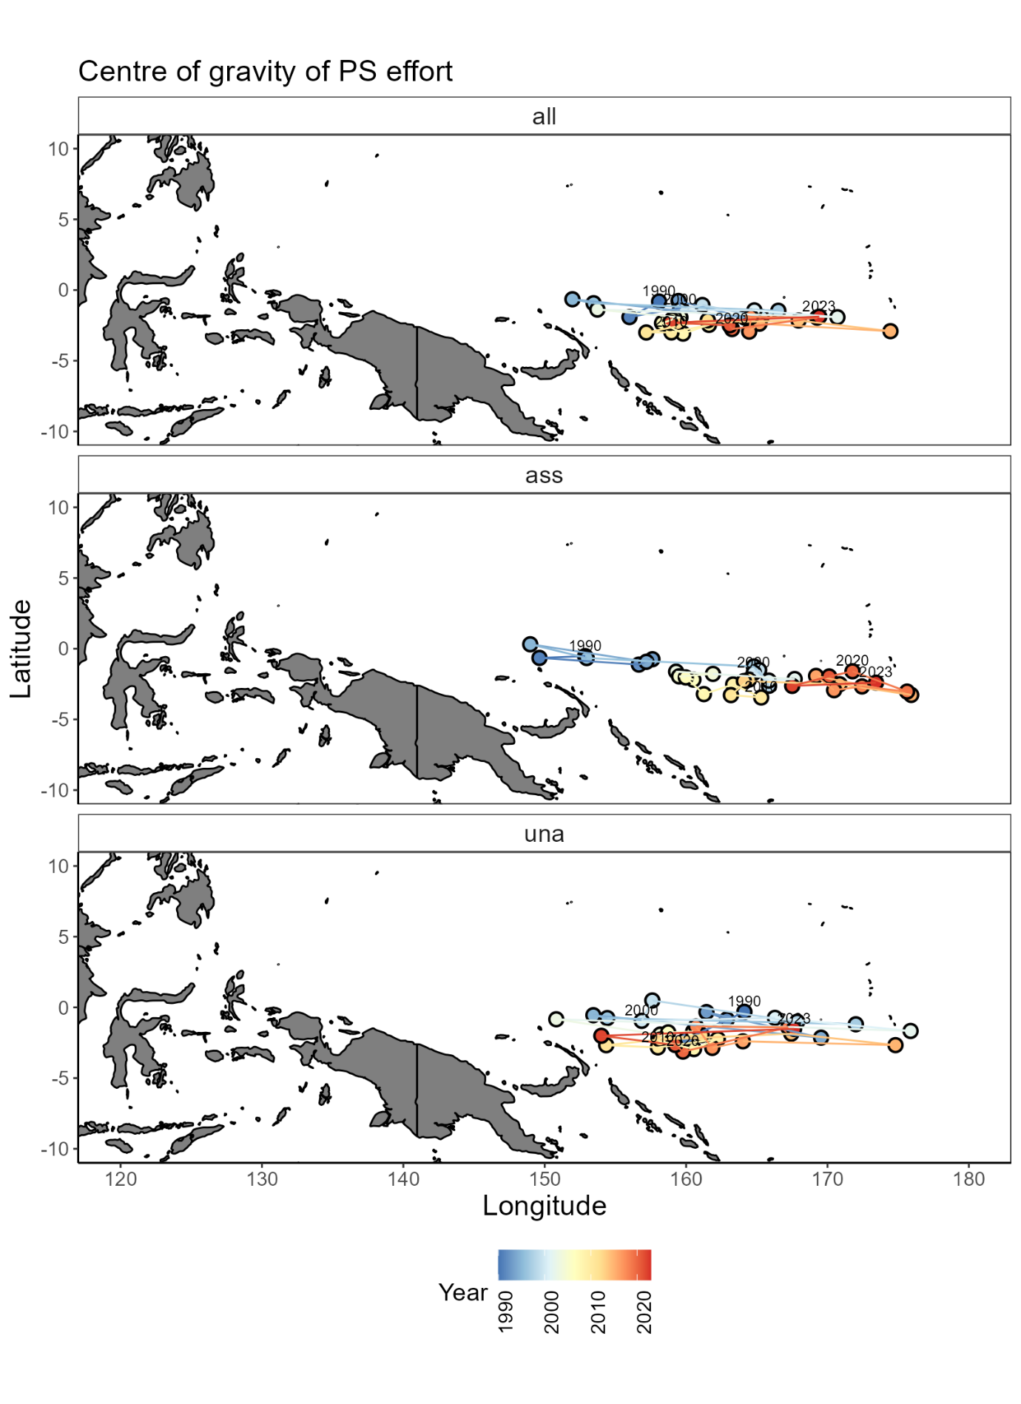

Figure 1: Centre of gravity of WCPFC purse seine effort by set type: all sets (all), drifting FAD-associated sets (ass), and free-school unassociated sets (una) from 1990-2023.

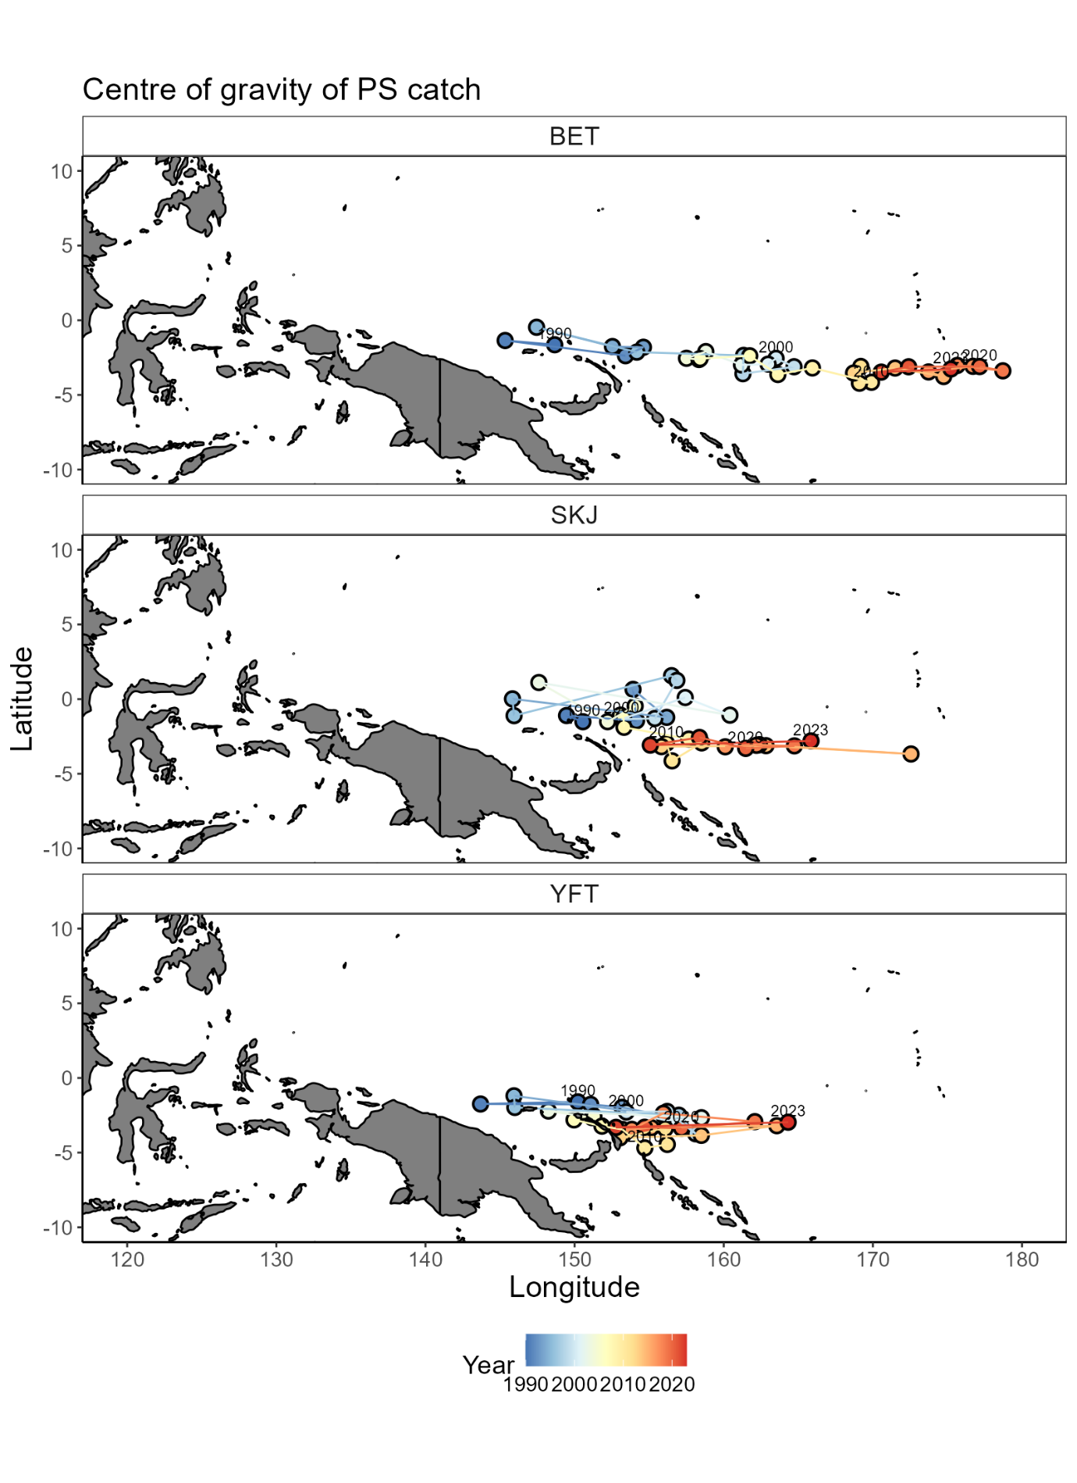

Figure 2: Centre of gravity of WCPFC purse seine catch of bigeye tuna (BET), skipjack tuna (SKJ), and yellowfin tuna (YFT) from all sets from 1990-2023.

Figure 3: Comparison of indices used to monitor the longitudinal distribution of the WCPFC purse seine fishery from 1990-2023. Black = modelled longitude. Red = unstandardised mean longitude of effort. Blue = COG of catch. Green = COG of effort. Dashed black = Mean longitude from 1995-2005.

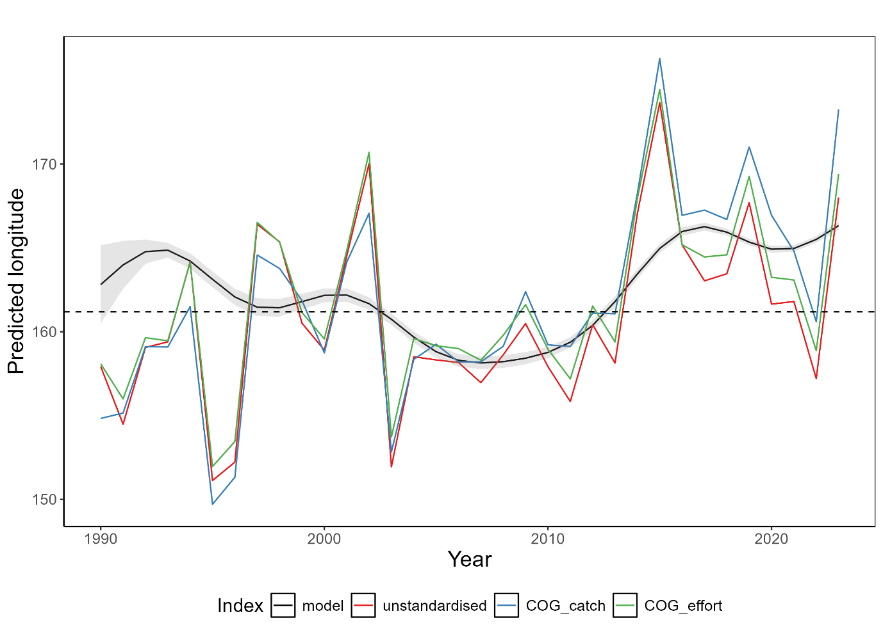

## Indicator X: Size composition of tunas

Rationale:The size composition of a fish population is influenced by a range of factors including fishing and its environment. For example, changing oceanographic conditions could influence prey availability having knock-on effects to fish size composition. How the environment and climate change is influencing tuna size composition is not well known. However, by monitoring tuna size composition, any changes can be identified which can help determine sustainability of the fishery and inform management decisions.

Status:Trends in the size composition of tunas has varied from 1990-2023 (Figure 4; Figure 5). This is likely a reflection of several factors including changes in sampling design, fishing behaviour, and the underlying environment and populations.

For bigeye tuna (BET), their size composition has fluctuated over time rising to values above the 1990-2000 average of 122cm from 2007-2012 before declining to approximately 2018. In recent years, length composition has increased and the mean length in 2023 of 125cm is above the historical mean. Throughout this time, most BET catches in the longline fishery are above the length at 50% maturity of 103cm (Farley et al., 2017).

For SKJ, their size composition has been more variable which is likely a reflection of fishing and sampling programs. In recent years, SKJ size composition has declined with nearly 75% of the length composition below the historical mean length of 51.3cm in 2022. Unlike YFT and BET, catches have predominately been below the length at 50% maturity of 55cm which is in part due to most catch and sampling coming from the purse seine fishery (Ohashi et al., 2019).

For YFT, a decline in their size composition since 2012 is apparent. From 2000-2010, they show a similar trend to BET where their size composition declined in the early 2000s before rising around 2010. However, in contrast to BET their size composition has since declined and consistently remained below the historical mean value of 120.8cm since 2012, with a 2023 mean length of 113.9cm. Like BET, most of the size composition remains above the length at 50% maturity of 105cm (Magnusson et al., 2023).

For both BET and YFT, there is a slight upward trend in the proportion of small fish caught (<105cm), and a decrease in the proportion of large fish caught (>140cm) throughout the timeseries (Figure 5). However, this trend is not clear, and recent years have shown a shift in the opposing direction. This could be due to several reasons including increased fishing pressure driving the removal of large individuals from the population, an increase in small individuals in the population from enhanced recruitment, or a consequence of disrupted sampling programs due to COVID19 for example. There were no clear trends in the size composition of SKJ, with slightly positive trends in both the number of small (<45cm) and large fish (>63cm) being sampled over time.

Description:Length composition data for the three tuna species were derived from observer and port sampling programs from SPC databases for the years 1990-2023. Longline data was used for BET and YFT, and a combination of longline and purse seine data for SKJ. Where required, total (or other) lengths were converted to fork length measurements using well established conversion factors (Macdonald et al., 2023, 2022). Any outliers in the data were removed and length composition metrics extracted. This included estimating a three-year rolling mean of: 1) small fish: the percentage of fish that were below the 20th percentile of fish sampled from 1990-2000, 2) mean fish: the percentage of fish above the mean length of fish sampled from 1990-2000, and 3) big fish: the percentage of fish above the 80th percentile of fish sampled from 1990:2000. By monitoring these three indicators rather than just the mean length, an improved understanding of a species size composition is gained.

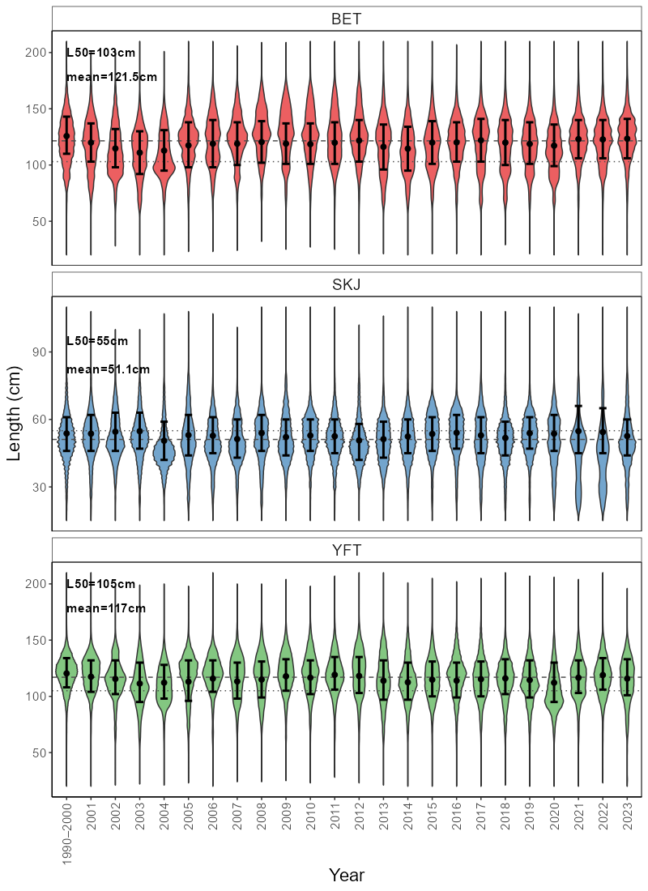

Figure 4: Length composition (cm) of bigeye tuna (BET), skipjack tuna (SKJ), and yellowfin tuna (YFT) in WCPFC longline fisheries (plus purse seine for SKJ) from 1990-2023. Dashed line = mean length from 1990-2000, dotted line = length at 50% maturity. Black dot = mean length with 25th-75th percentile error bars.

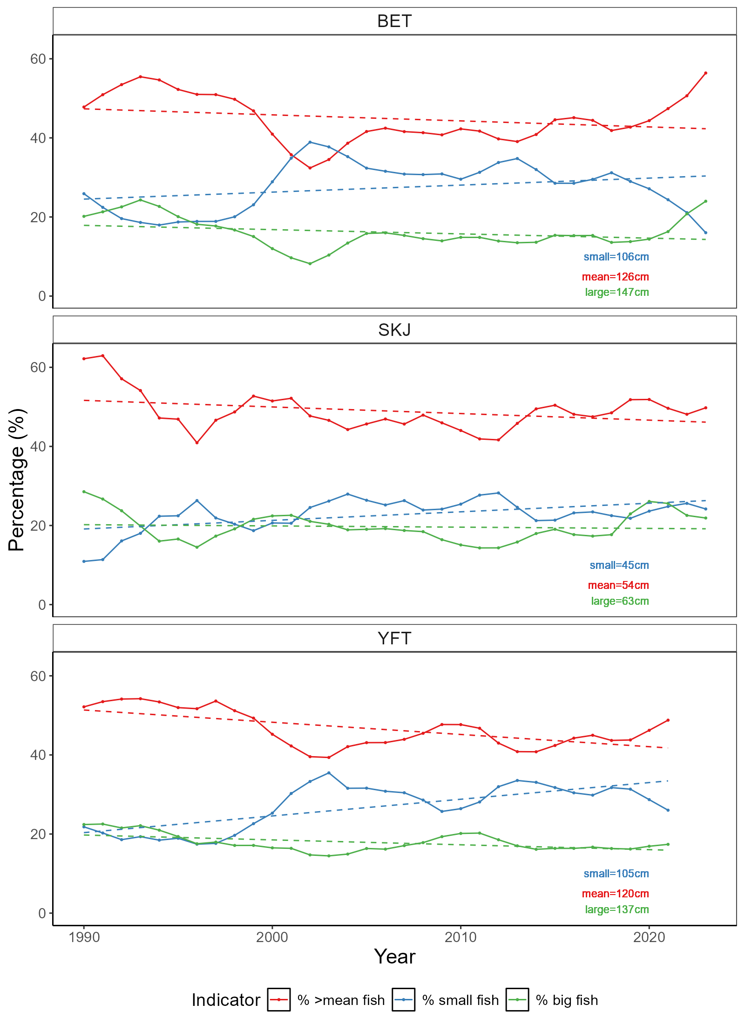

Figure 5: Length indicators for bigeye tuna (BET), skipjack tuna (SKJ), and yellowfin tuna (YFT) in WCPFC longline fisheries (plus purse seine for SKJ) from 1990-2023. Blue = % of fish below the 20th percentile measured from 1990-2000. Red = % of fish above the mean length measured from 1990-2000. Green = % of fish above the 80th percentile of fish measured from 1990-2000. Dashed lines represent linear models fit to each line to get a general trend line.

# References

Allain, V., Hare, S., Macdonald, J., Machful, P., Nicol, S., Phillips, J.S., Portal, A., Vidal, T., Williams, P., 2021. WCPO Ecosystem and Climate Indicators from 2000 to 2020. Online.

Allain, V., Macdonald, J., Nicol, S., Phillips, J.S., Vourey, E., 2020. Ecosystem and climate indicators for consideration within the WCPO. Online.

Anon, 2015. Summary Report: Commission for the Conservation and Management of Highly Migratory Fish Stocks in the Western and Central Pacific Ocean. Pohnpei.

Ashida, H., 2020. Spatial and temporal differences in the reproductive traits of skipjack tuna Katsuwonus pelamis between the subtropical and temperate western Pacific Ocean. Fish Res 221, 105352. https://doi.org/10.1016/j.fishres.2019.105352

Bell, J.D., Allain, V., Allison, E.H., Andréfouët, S., Andrew, N.L., Batty, M.J., Blanc, M., Dambacher, J.M., Hampton, J., Hanich, Q., Harley, S., Lorrain, A., McCoy, M., McTurk, N., Nicol, S., Pilling, G., Point, D., Sharp, M.K., Vivili, P., Williams, P., 2015. Diversifying the use of tuna to improve food security and public health in Pacific Island countries and territories. Mar Policy 51, 584–591. https://doi.org/10.1016/j.marpol.2014.10.005

Bell, J.D., Senina, I., Adams, T., Aumont, O., Calmettes, B., Clark, S., Dessert, M., Gehlen, M., Gorgues, T., Hampton, J., Hanich, Q., Harden-Davies, H., Hare, S.R., Holmes, G., Lehodey, P., Lengaigne, M., Mansfield, W., Menkes, C., Nicol, S., Ota, Y., Pasisi, C., Pilling, G., Reid, C., Ronneberg, E., Gupta, A. Sen, Seto, K.L., Smith, N., Taei, S., Tsamenyi, M., Williams, P., 2021. Pathways to sustaining tuna-dependent Pacific Island economies during climate change. Nat Sustain 4, 900–910. https://doi.org/10.1038/s41893-021-00745-z

Farley, J., Eveson, P., Krusic-Golub, K., Sanchez, C., Roupsard, F., Mckechnie, S., Nicol, S., Leroy, B., Smith, N., Chang, S.-K., 2017. Project 35: Age, growth and maturity of bigeye tuna in the western and central Pacific Ocean. Rarotonga.

Fujioka, K., Aoki, Y., Tsuda, Y., Okamoto, K., Tsuchida, H., Sasaki, A., Kiyofuji, H., 2024. Influence of temperature on hatching success of skipjack tuna (Katsuwonus pelamis): Implications for spawning availability of warm habitats. J Fish Biol 105, 372–377. https://doi.org/10.1111/jfb.15767

Gillett, R., Fong, M., 2023. Fisheries in the Economies of Pacific Island Countries and Territories (Benefish Study 4). Noumea.

Griffiths, S., Fuller, L., 2019. Ecosystem Considerations. San Diego.

Juan-Jordá, M., Murua, H., Apostolaki, P., Lynam, C., Rodriguez, A., Barrionuevo, J., Abascal, F., Coelho, R., Todorovic, S., Billet, N., Uyarra, M., Andonegi, E., Lopez, J., 2019. Selecting ecosystem indicators for fisheries targeting highly migratory species: An EU project to advance the operationalization of the EAFM in ICCAT and IOTC. Pohnpei.

Juan-Jordá, M.J., Murua, H., Arrizabalaga, H., Hanke, A., 2018. A template for an indicator-based ecosystem report card for ICCAT, Sci. Pap. ICCAT.

Lehodey, P., Bertrand, A., Hobday, A.J., Kiyofuji, H., McClatchie, S., Menkès, C.E., Pilling, G., Polovina, J., Tommasi, D., 2020. ENSO Impact on Marine Fisheries and Ecosystems, in: Geophysical Monograph Series. John Wiley and Sons Inc, pp. 429–451. https://doi.org/10.1002/9781119548164.ch19

Lehodey, P., Chai, F., Hampton, J., 2003. Modelling climate-related variability of tuna populations from a coupled ocean-biogeochemical-populations dynamics model. Fish Oceanogr 12, 483–494.

Lehodey, P., Senina, I., Calmettes, B., Hampton, J., Nicol, S., 2013. Modelling the impact of climate change on Pacific skipjack tuna population and fisheries. Clim Change 119, 95–109. https://doi.org/10.1007/s10584-012-0595-1

Macdonald, J., Williams, P., Roupsard, F., Sanchez, C., Bell, L., Chang, S.-K., Contreras, R., Ghergariu, M., Hosken, M., Hoyle, S., Cuu, S.N., Park, T., Potts, J., Schneiter, E., Nicol, S., 2023. Project 90 update: Better data on fish weights and lengths for scientific analyses. Koror.

Macdonald, J., Williams, P., Sanchez, C., Schneiter, E., Prasad, S., Ghergariu, M., Hosken, M., Panizza, A., Park, T., Guillou, A., Nicol, S., 2022. Project 90 update: Better data on fish weights and lengths for scientific analyses. Online.

Magnusson, A., Day, J., Teears, T., Hampton, J., Davies, N., Castillo Jordán, C., Peatman, T., Scott, R., Scutt Phillips, J., Mckechnie, S., Scott, F., Yao, N., Natadra, R., Pilling, G., Williams, P., Hamer, P., 2023. Stock assessment of yellowfin tuna in the western and central Pacific Ocean: 2023. Koror.

Ohashi, S., Aoki, Y., Tanaka, F., Fujioka, K., Aoki, A., Kiyofuji, H., 2019. Reproductive traits of female skipjack tuna Katsuwonus pelamis in the western and central Pacific Ocean (WCPO). Pohnpei.

Senina, I., Sibert, J., Lehodey, P., 2008. Parameter estimation for basin-scale ecosystem-linked population models of large pelagic predators: Application to skipjack tuna. Prog Oceanogr 78, 319–335. https://doi.org/10.1016/j.pocean.2008.06.003

Smith, N., Allain, V., Pilling, G., 2016. Ecosystem indicators: moving forward to design and testing. Bali.

SPC, 2024. Ecosystem and climate indicators. Manila.

SPC, 2023. Ecosystem and Climate Indicators. Koror.

SPC, 2022. Ecosystem and climate indicators. Online.

Taylor, N.G., Walter, J.F., 2024. Incorporating climate considerations into fisheries assessments and management advice at ICCAT, Collect. Vol. Sci. Pap. ICCAT.

Vidal, T., Hamer, P., Escalle, L., Pilling, G., 2020. Assessing trends in skipjack tuna abundance from purse seine catch and effort data in the WCPO.

Weller, E., Min, S.K., Cai, W., Zwiers, F.W., Kim, Y.H., Lee, D., 2016. Human-caused Indo-Pacific warm pool expansion. Sci Adv 2, e1501719. https://doi.org/10.1126/sciadv.1501719

# Appendix 1: Terms of reference for adopting ecosystem and climate indicators

The text below was extracted from (SPC, 2023).

### Terms of Reference

*A drafted terms of reference for the Ecosystem and Climate Indicators project was provided as Annex 3 to SC18-EB-WP-01 with the following specified objectives and scope of work:*

##### Objectives

* *Develop and test candidate ecosystem and climate indicators to track the impact of climate and ecosystem changes on WCPFC fisheries and ecosystems.*
* *Provide technical advice to the Scientific Committee on the suitability of criteria used for testing and evaluating the performance of candidate indicators.*
* *Support the Scientific Committee in developing tools to communicate ecosystem and climate change impacts to WCPFC and external stakeholders and interest groups.*

##### Scope of Work

* *Technical analyses to develop and test candidate indicators.*
* *WCPFC member and expert workshops to refine indicators.*
* *Scientific Committee reporting.*
* *Routine preparation of adopted indicators.*
* *Development of tools for communication to WCPFC and wider stakeholders.*

*The SSP was tasked by SC18 to develop a workplan for this project to be endorsed by SC19 and to develop an associated budget.*

### Process for adopting indicators

*SC12 noted that developing a thorough understanding of how to interpret potential indicators, their appropriate reference levels and baselines, and how reliable they are for prediction were critical steps for indicator adoption by the WCPFC Scientific Committee (SC). Criteria for developing and testing candidate indicators has subsequently been proposed to the Scientific Committee:*

* *science and data based;*
* *characterize the states and trends of WCPFC marine ecosystems with respect to fishing activity and/or climate (including reference levels and baselines);*
* *reflect well-defined processes underlying fishing activity and fishery responses to climate;*
* *responsive to changes attributable to fishing pressure and climate (i.e. having minimal time-lags and capability to provide early warning);*
* *estimable on a routine basis with a historical data time-series available;*
* *cost-effectiveness;*
* *scalable across national, sub-regional and regional scales;*
* *linked to existing WCPFC models and decision-making processes (for inclusion in MSE scenarios, validation of predictions and testing of model assumptions);*
* *can be routinely estimated by members without reliance on the Science Service Provider.*

# Appendix 2: Suva ecosystem and climate indicators workshop summary

An ecosystem and climate indicators workshop was held in Suva, Fiji November 25-26th 2024 at SPC Nabua campus. This workshop brought together approximately 25 participants both in person and online from a range of organisations including SPC, NOAA, WCPFC, private sector, NGOs and member country representatives. The intent of this workshop was to discuss the development of a series of indicators that accurately detail the current marine climate for the Pacific region and its fisheries so that it can better monitor and adapt to the effects of climate change.

Over the two days, a range of presentations and discussions were held discussing:

* the terms of reference and framework decided upon by SC to guide indicator development;
* Potential climate-related indicators and major oceanographic features of the WCPO;
* Potential fisheries and ecosystem-related indicators;
* Exploration of how indicators can be designed and tested to best monitor the ecosystem and climate.

Outcomes from this workshop included the detailing of a workplan to develop an ecosystem and climate indicators report with the intent to deliver this report and its outcomes to WCPFC Commission meeting in November 2025.

## Workshop agenda

**WCPFC Climate Indicators**

**Draft Agenda**

Monday 25th November 2024, Fei Finomo Meeting Room Room, SPC Nabua (2nd Floor Lotus), Suva, Fiji, 9:30am-16:00pm

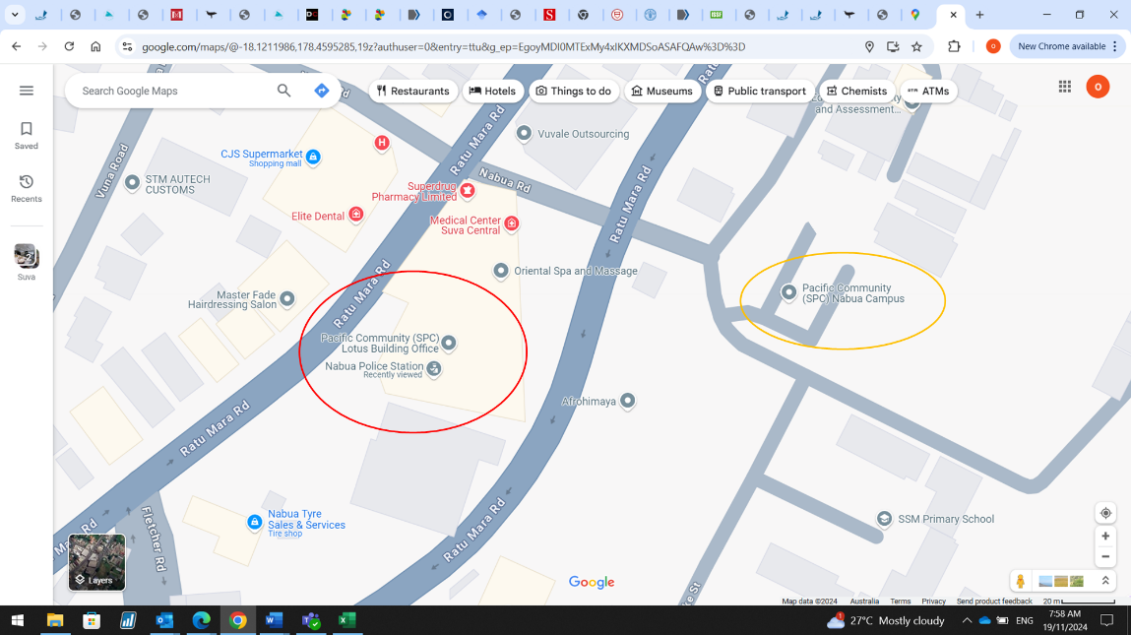

SPC has two campuses in Nabua. Our meeting is in the Lotus building (2nd Floor) (see red circle on screenshot). The Lotus building is above the Nabua police station. Entrance to the right of the police station entrance. If you get dropped off at the main campus (orange circle on screenshot) it’s a short 200m walk to the lotus building.

|  |
| --- |
| Agenda Item |
| 1. Introduction |
| 1. WCPFC Climate Indicators Overview    1. Indicator Framework    2. Candidate Regional Indicators |
| 1. Climate Indicators    1. Ocean State Reporting    2. National and Regional Ocean Indicators & Trends |
| 1. Fisheries Tuned Indicators    1. SDM    2. SEAPODYM    3. Fisheries    4. Decision related |
| 1. Framework for testing    1. Breakpoints    2. Track CC impacts    3. Empirical vrs Modelled |
| 1. Reporting    1. Met Services    2. Portals |

Tuesday 23rd November 2024, Fei Finomo Meeting Room Room, SPC Nabua (2nd Floor Lotus), Suva, Fiji, 9:30am-12:00pm

WCPFC Climate Indicators

|  |  |
| --- | --- |
|  | 1. Co-design/Resourcing    1. Collaboration network    2. Data Access |
|  | 1. Work plan |

## Workshop participants

|  |  |
| --- | --- |
| **Participant** | **Organisation** |
| Bernadette Sloyan | CSIRO, Australia |
| Bipendra Prakash | SPC, Fiji |
| Jone Amoe | SPC, Fiji |
| Naiten Bradley Phillip Jr | SPC, Federated States of Micronesia |
| Francis Tofuakalo | SPC, Solomon Islands |
| Nick Hill | SPC, New Caledonia |
| Simon Nicol | SPC, New Caledonia |
| Tuikolongahau Halafihi | SPC, New Caledonia |
| Victoria Pilbeam | SPC, New Caledonia |
| Lui Bell | SPC, Tonga |
| Lilis Sadiyah | NRIA, Indonesia |
| Fayakun Satria | NRIA, Indonesia |
| Emily Crigler | NOAA, USA |
| Felipe Carvalho | NOAA, USA |
| Ryan Rykaczewski | NOAA, USA |
| Pheobe Woodworth-Jercoats | NOAA, USA |
| Nicholas Ducharme-Barth | NOAA, USA |
| Glen Holmes | PEW, Australia |
| Johann Bell | Conservation International, Australia |
| Kara Miller | Conservation International, USA |
| Andrew Bassford | Marine Change, Hong Kong |
| Elaine Garvilles | WCPFC, FSM |
| SungKwon Soh | WCPFC, Federated States of Micronesia |